Step 1: Go to Github. **https://github.com**

Sign up for an account by creating a new username and putting in an e-mail address that you already have. Choose a password.

If a pink box appears, read it. It will tell you that your username or password is not acceptable and needs to be changed. Usernames need to be just letters and numbers (no spaces). Passwords need to have letters and numbers and must be long enough.

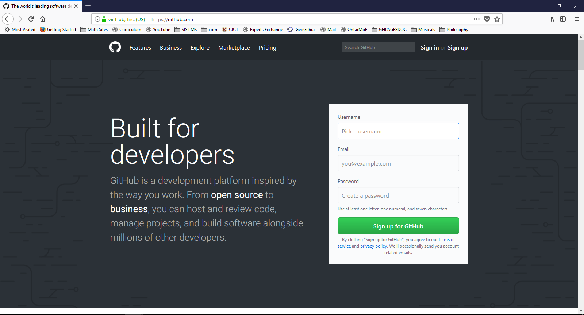

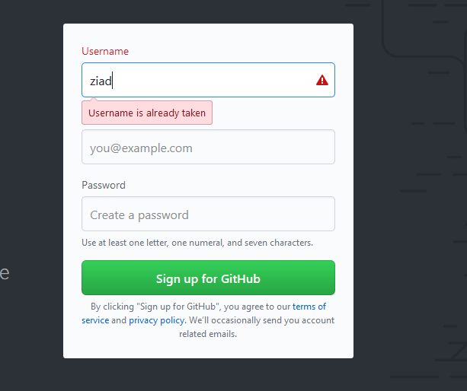



Step 2. Choose the free plan. Don’t check the boxes at the bottom.

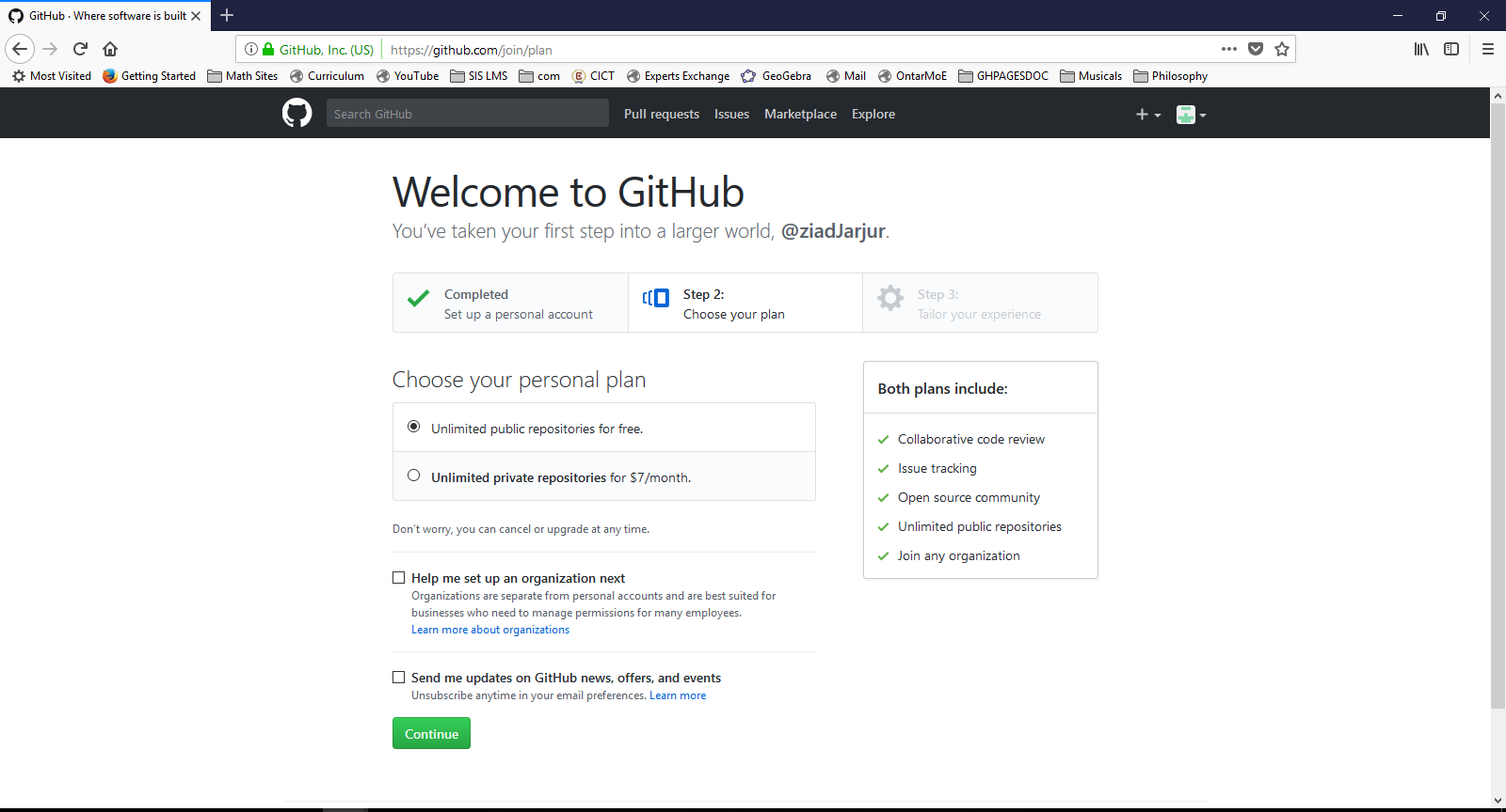

On the next page, you don’t actually need to fill in anything. Just skip it.

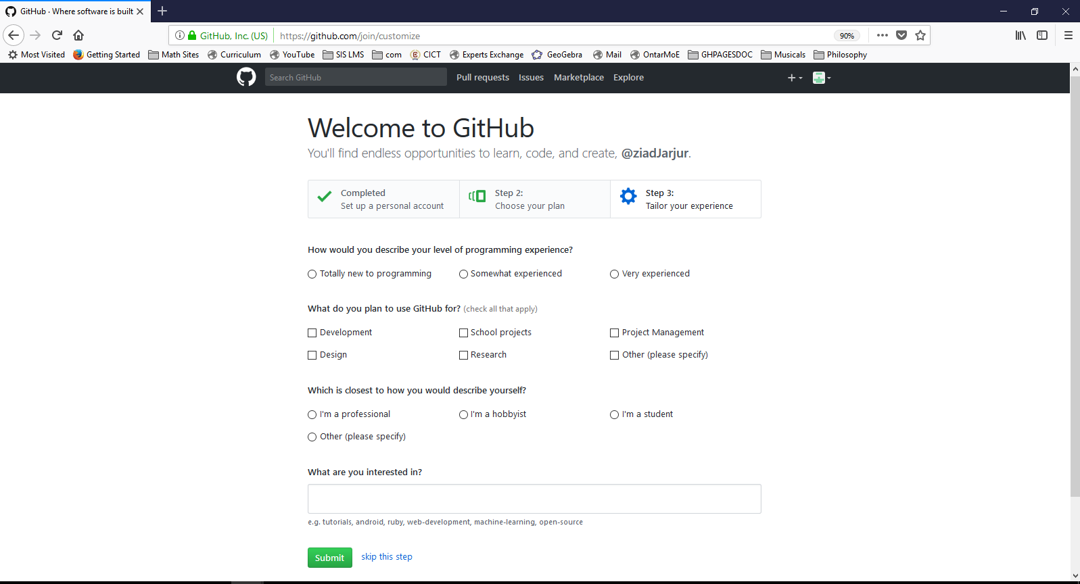

Step 3: Go to your email and open the message from Github to verify your e-mail address.

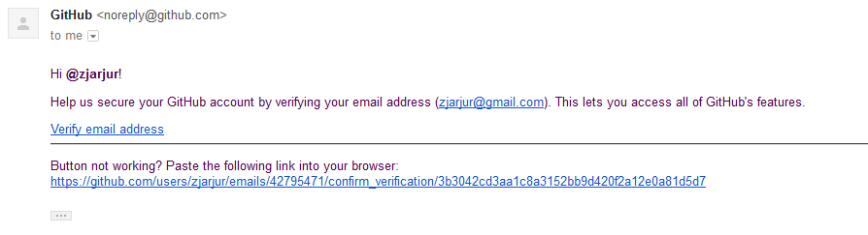

You can just click on the bottom link to verify your e-mail.

Step 4: Now we need to get the desktop app from this website:

[**https://desktop.github.com**](https://desktop.github.com)

Go there and press the big download button

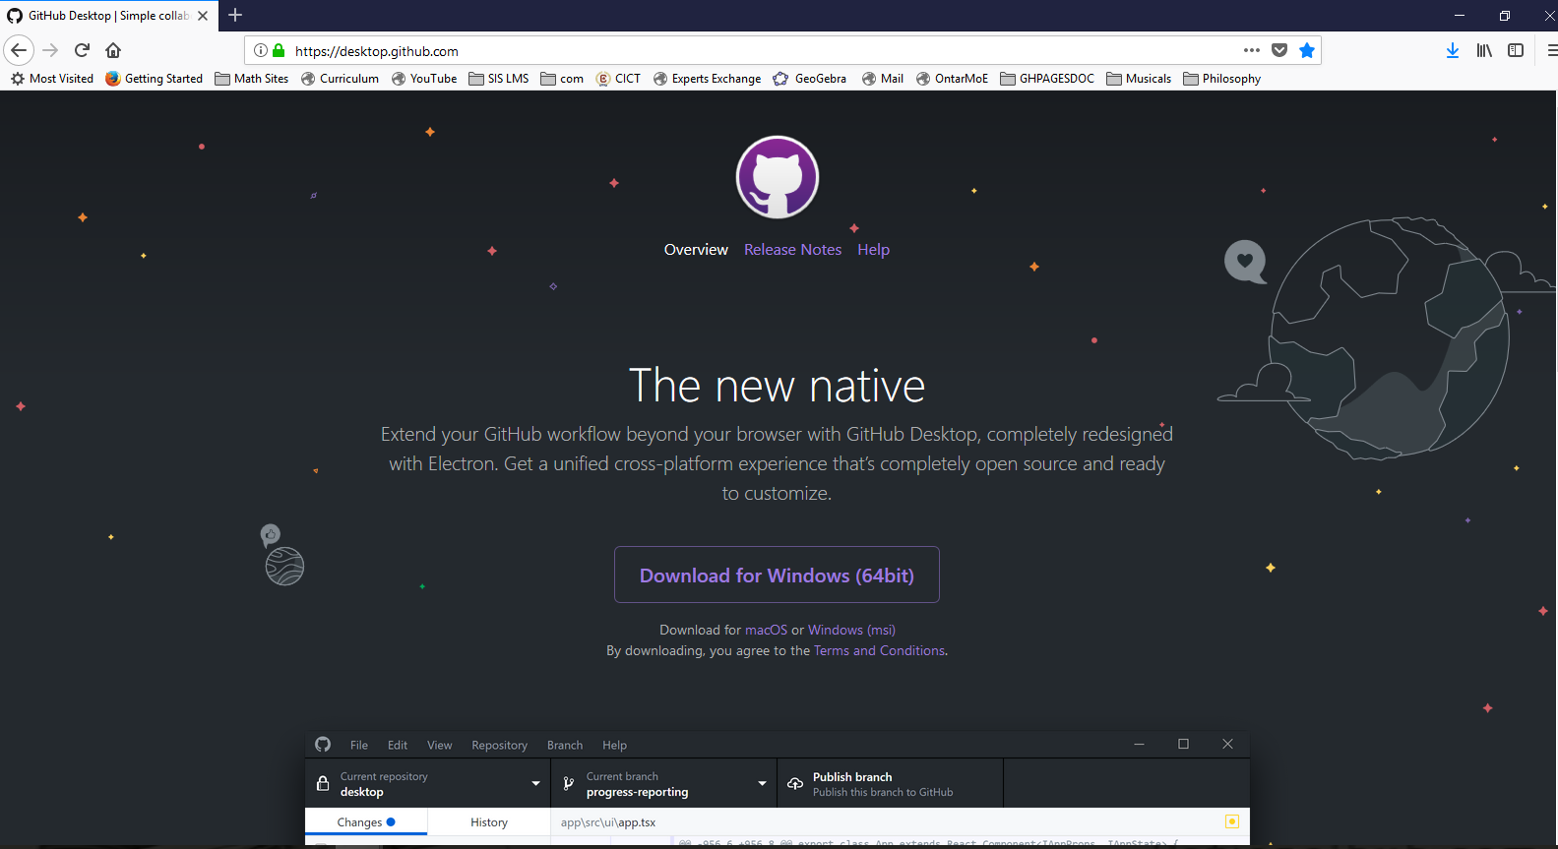

Install it and open it.

Step 5: Use the desktop app to “Sign in to Github.com”

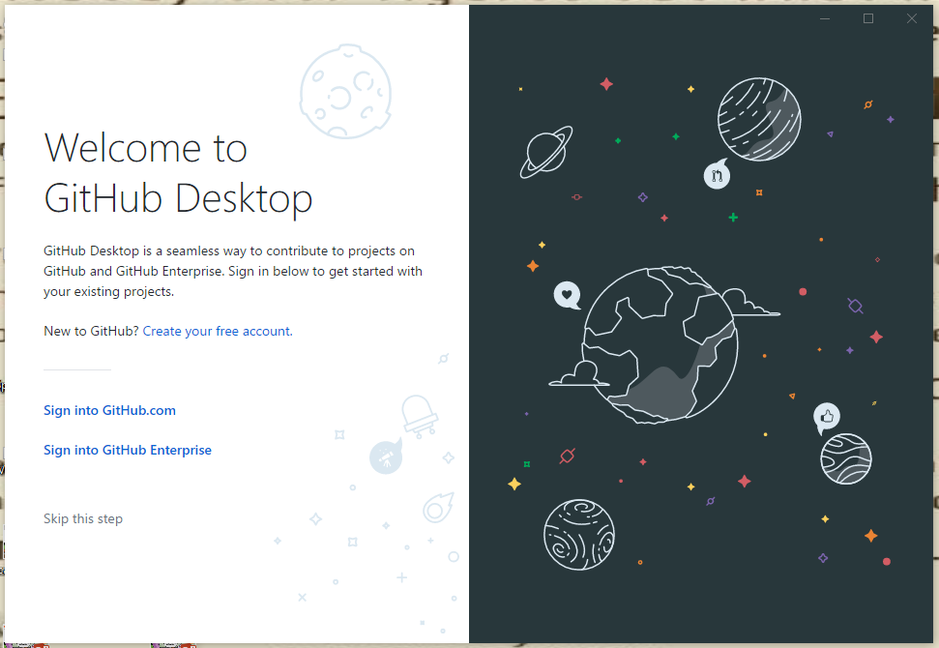

Sign in to your new desktop app using your github username and password:

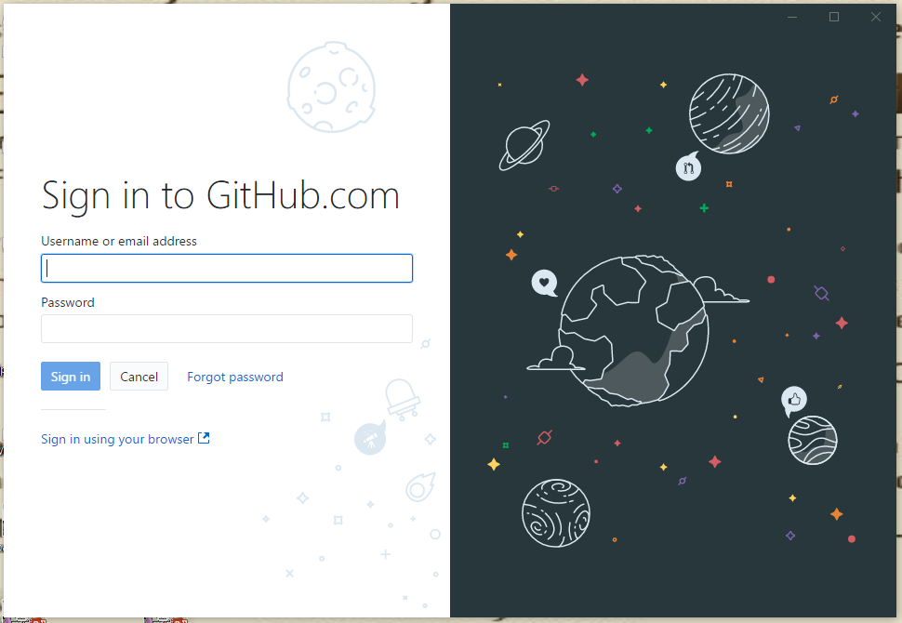

On the next page, don’t change anything, just press the blue button (“continue”)

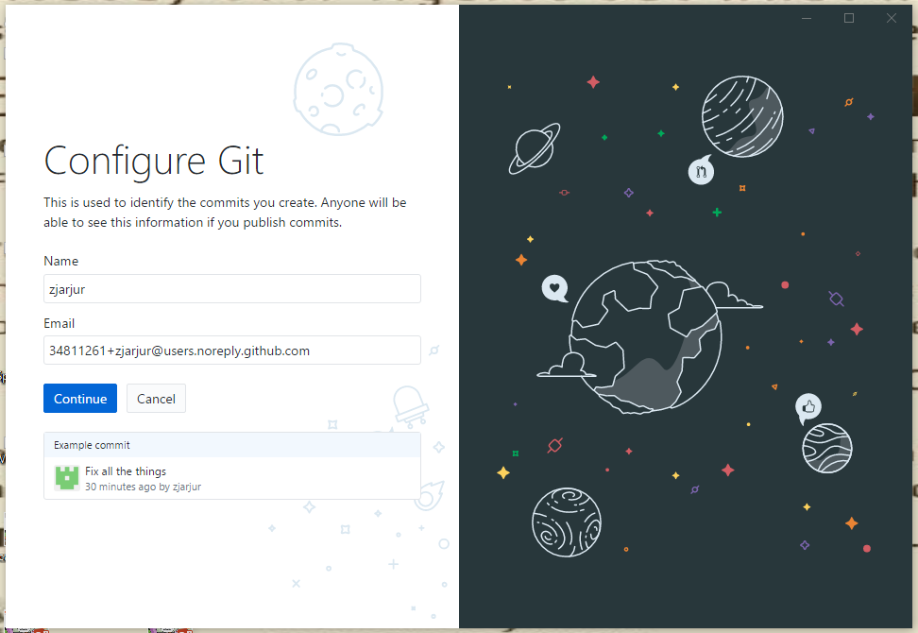

Finally push the blue button that says “Finish”

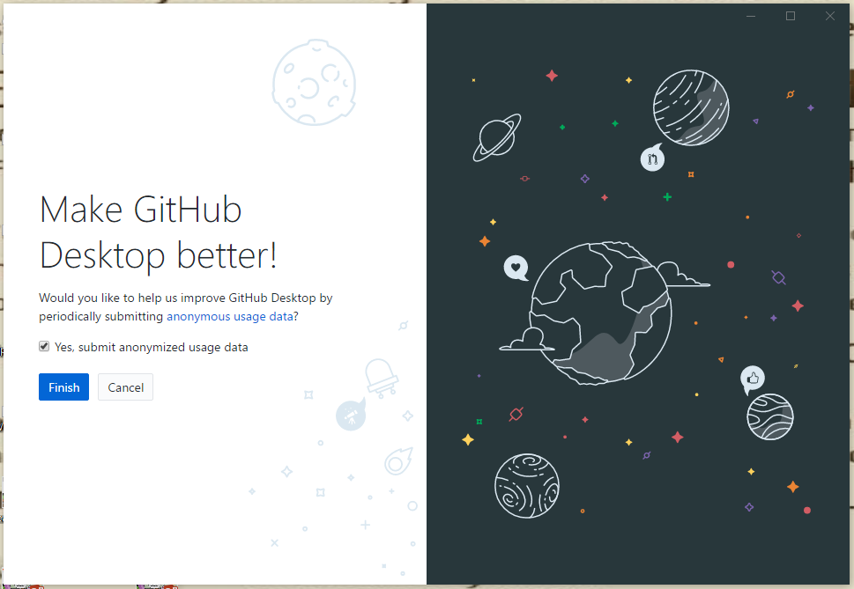

Step 6: Test that everything is working ok. (Show this to the teacher for an assignment grade of 100:

Windows: Click “File” and “options” to see the account info.:

Mac: Click “Github Desktop” and “Preferences” to see the account info.:

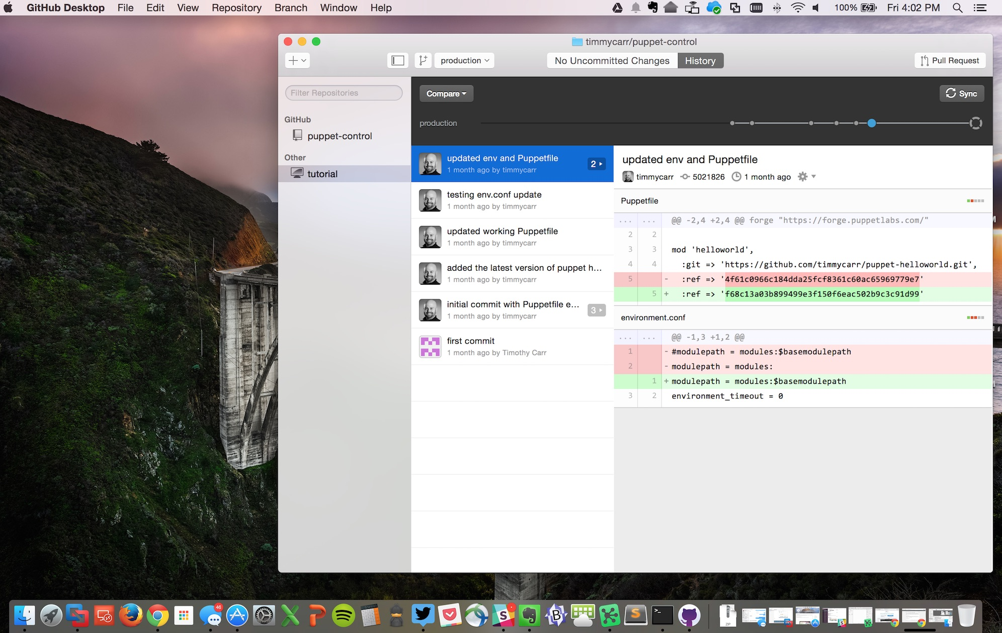

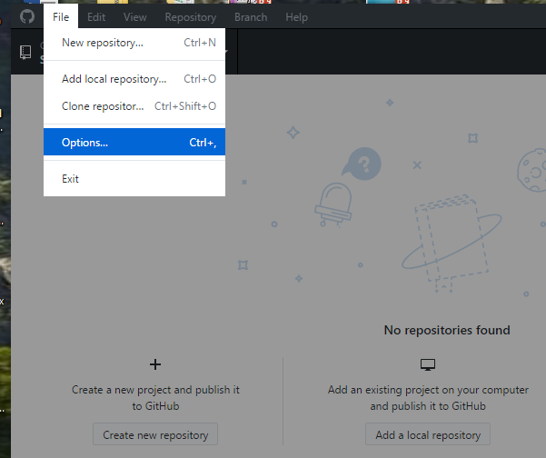

Show the account info to the teacher.

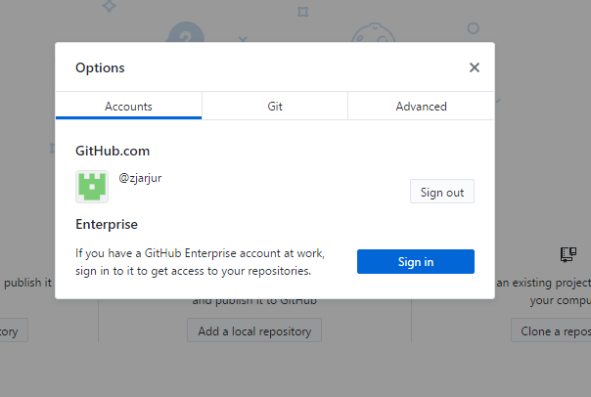

If you don’t see your account info. You did something wrong somewhere. If you see it, you’re fine. Show the teacher.

Step 7. Now we will put our website on the internet. First make sure you followed the basic instructions:

You should have a folder on your computer for your website.

That folder should have all of your website files inside.

That folder should ONLY have your website files inside. NOTHING ELSE!!!

One of the files inside should be your website code (your HTML).

That file MUST be named “index.html”

If you didn’t follow ANY of these instructions, fix it NOW!

If you have followed these instructions, you’re ready for the next step.

Step 8: Go to your github desktop app. Click on “File” and choose “Add local repository”

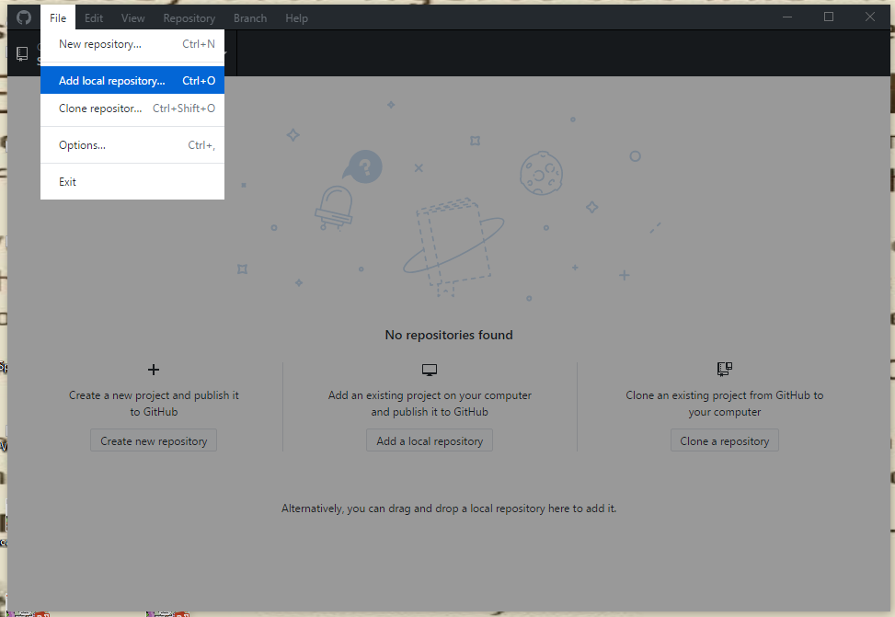

Click “Choose” and find the folder that has your website.

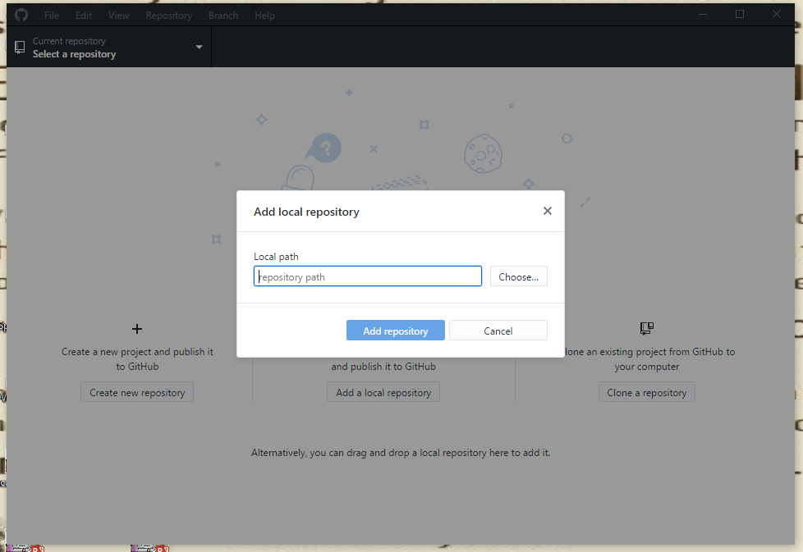

You are choosing the FOLDER. Not the files. EVERYTHING in the folder will be put on the internet. Don’t worry if you don’t see files (or you can’t choose the files) Just select the folder and click the button “Select Folder”.

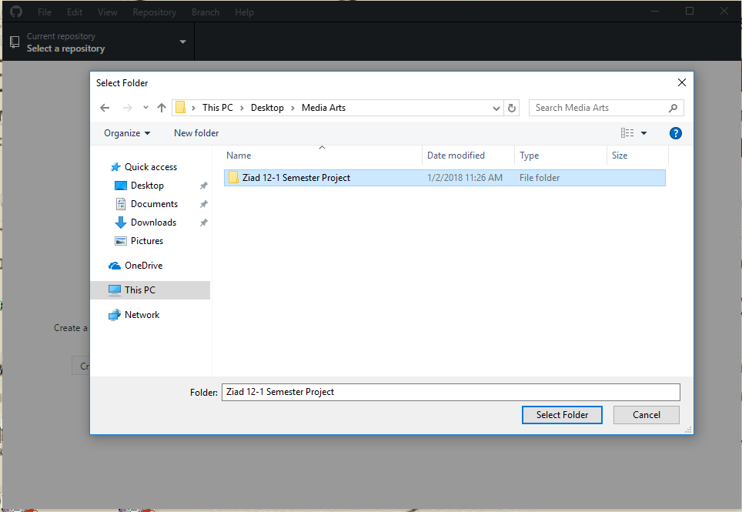

This part is weird! The big blue button DOESN’T work. That’s ok. You should actually click the small blue Link that says “create a repository”.

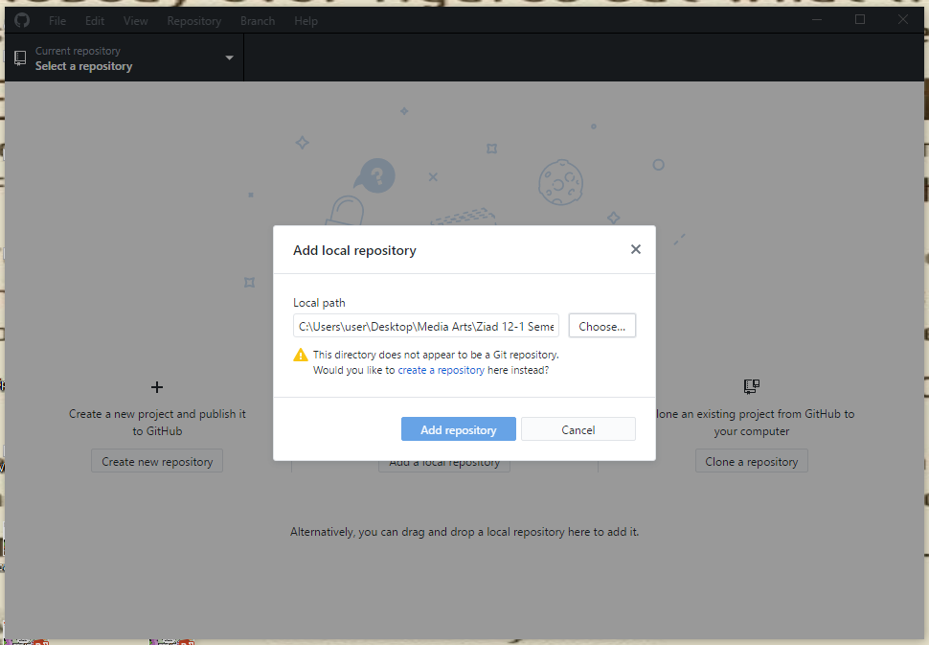

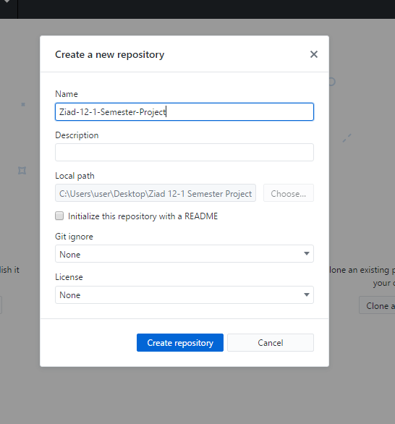

Don’t change anything in the next box.

Just click on “Create Repository”

Now, your screen should look like this:

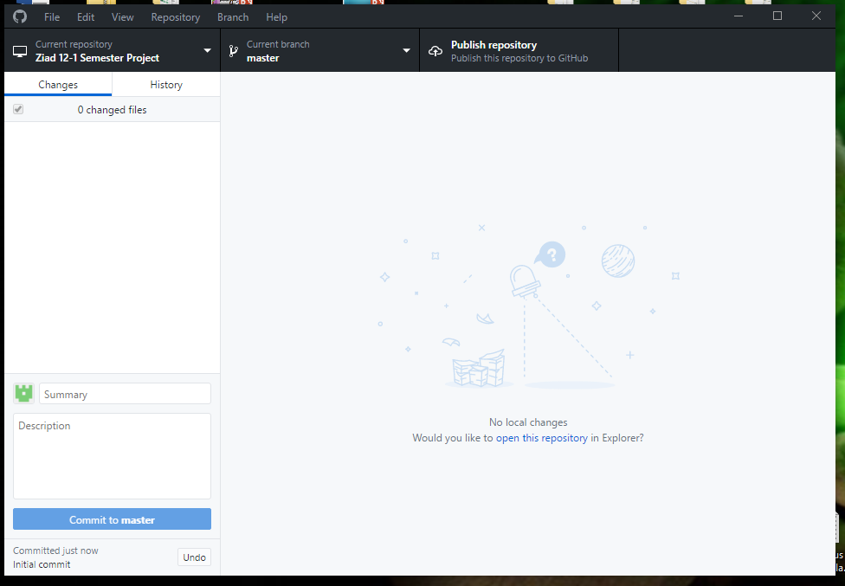

Step 9: Create a new branch. Click on “Branch” and choose “New branch”

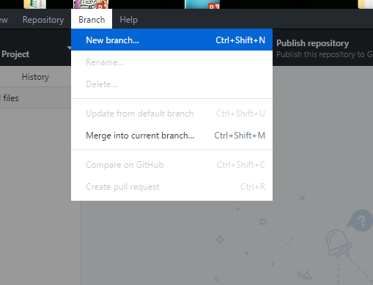

You MUST name the new branch **gh-pages**

Click on “create branch”

Step 10: Your page should look like this:

Press the button that says “Publish Repository”

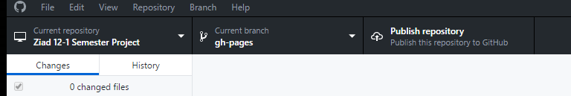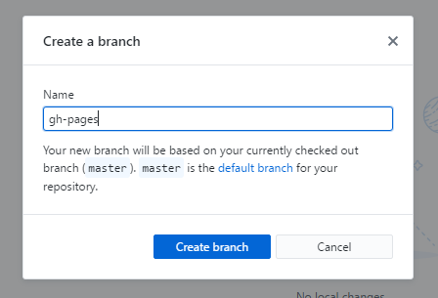

When the box pops up, you will make one change:

There is a box with a checkmark that says “Keep this code private”.

Remove the check mark.

WRONG RIGHT

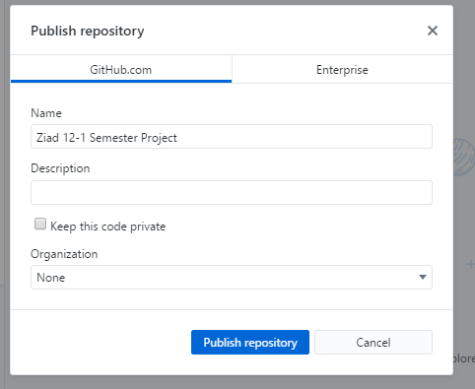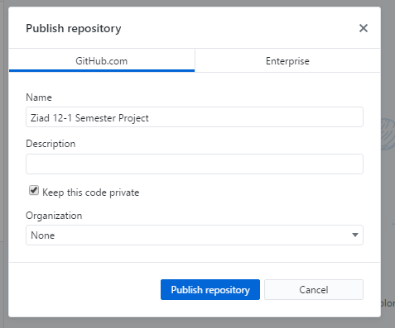

Press the blue button to “Publish Repository”

If you did this right, you now have a webpage on the internet.

But, where is it? And how will we fix it if there are mistakes?

Step 11: Go to your Github account on Github.com (We are NOT using the dektop app for this.)

On the bottom right is a list of all repositories. Click on the repository for your website (probably the only one there.)

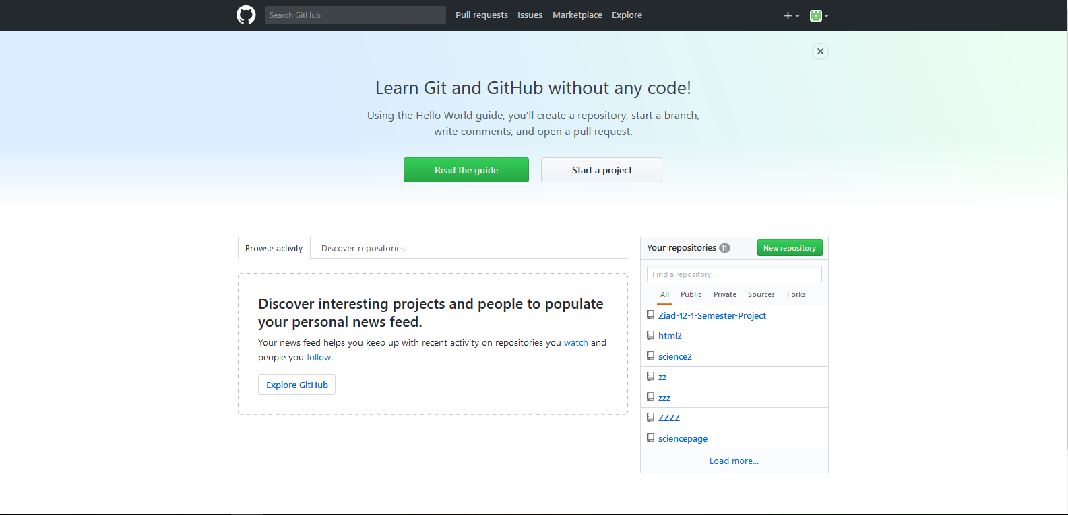

There are several things you can do here.

Clicking on index.html will let you see your html code. (There will also be a small pen picture on this page. clicking on the pen will let you edit, or rename your html). Be careful here. There is a button on this page that will delete your html, so don’t press it unless you really want to.

Clicking on “upload files” will let you add more pictures from your computer or another copy of your index.html (if you have already deleted the old copy).

Clicking on “settings” will let you see where your webpage is.

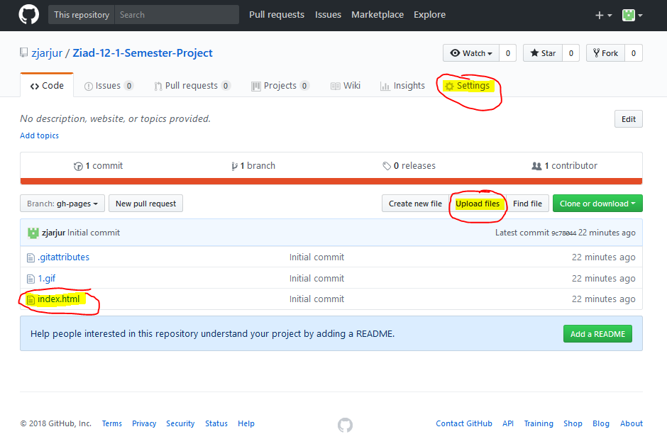

Editing a file or deleting a file:

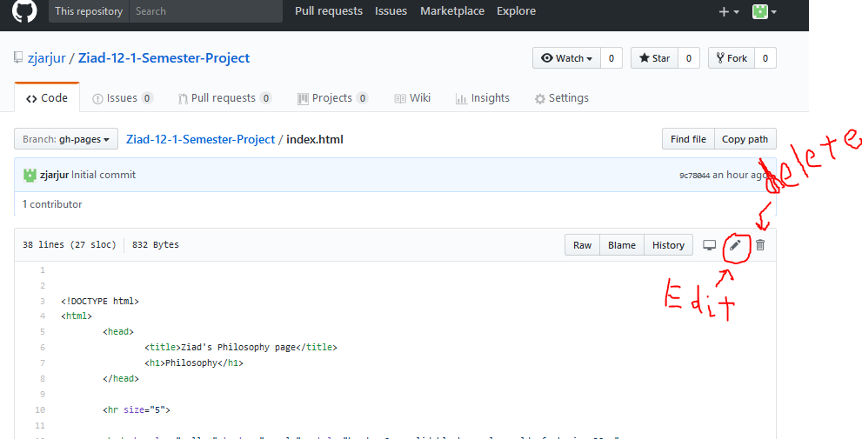

If you edit, you must click on “commit changes” at the bottom of the page to save your work.

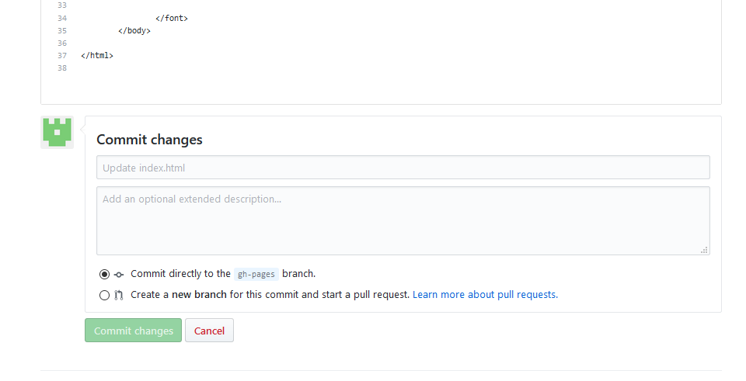

LAST STEP:

Under the setting item, you can find the address of your website. You must copy this address and send it to your teacher on Edmodo. Doing this will finish your final project. If you DON’T do this, you will get a zero on your final project.

After you click on “settings” move down until you find the section named “GitHub Pages”

This is what your address looks like:

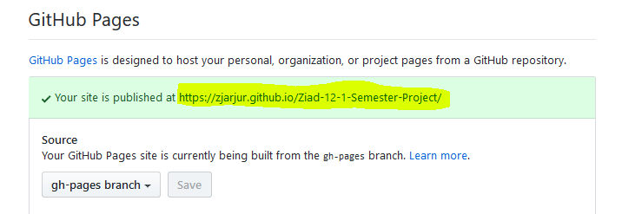

The section in yellow is the address of your webpage (It will not actually be yellow, but the box around it should be green.)

Make sure you click on the address to visit your page and make sure it looks ok.

When you feel it is finished, copy the address and send the address to your teacher.

That’s is, you’re finished!